RESOLUTION NO.__________

RE: CERTIFICATE OF APPROPRIATENESS UNDER THE
PROVISIONS OF THE ACT OF THE PENNSYLVANIA
LEGISLATURE 1961, JUNE 13, P.L. 282 (53
SECTION 8004) AND BETHLEHEM ORDINANCE NO.
3952 AS AMENDED.

WHEREAS, it is proposed to replace the garage doors at 925 W. Market Street.

NOW, THEREFORE, BE IT RESOLVED by the Council of the City of Bethlehem that a Certificate of Appropriateness is hereby granted for the work.

Sponsored by: (s)

(s)

ADOPTED BY COUNCIL THIS DAY OF

(s)
President of Council

ATTEST:

(s)
City Clerk

HISTORIC CONSERVATION COMMISSION

CASE # 501 – It is proposed to replace the garage doors at 925 W. Market Street.
OWNER/APPLICANT: Scarlett Spence

The Commission upon motion by Mr. Lader seconded by Ms. Starbuck adopted the proposal that City Council issue a Certificate of Appropriateness for the proposed work described herein:
- The proposal to replace the garage doors at 925 W. Market Street was presented by Scarlett Spence.
- The new garage doors will match the wood style doors with divided lights presented at the HCC meeting but may be fabricated in steel with vinyl overlay.
- The glass lights may be located at the top of the doors or a row lower.
- The color will be “Ecru” or similar to blend with the beige trim color on the house.
- The proposed motion was unanimously approved.

CU: cu

By: 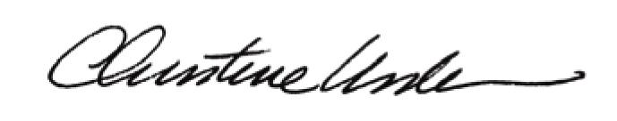

Date of Meeting: June 16, 2014 Title: Historic Officer

